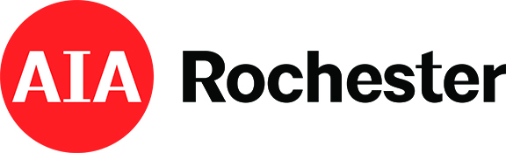
2022 AIA Rochester’s Medal of Distinction Call for Entries
Sponsored by: AIA Rochester

The Medal of Distinction, recognized as the highest individual award that AIA Rochester can bestow on its members, is meant to celebrate lifetime service to the profession, the chapter and the community.

Please fill out the information below, using separate sheets as necessary, and return to the Chapter Office by September 1, 2022 at 5:00 PM.

Nominee Name: _____________________________________________________________________

Original Submission Date: ______________________________________________________________

AIA involvement: (Local, State, & National, Contribution to the profession, Commitment to the chapter, Community & Advocacy):

Significant accomplishments in the profession:

Attach nominee business resume and nomination letter.

